Ideation Phase

Brainstorm & Idea Prioritization

|  |  |
| --- | --- |
| Date | 21 October 2022 |
| Team ID | PNT2022TMID23850 |
| Project Name | IoT Based Smart Crop Protection System For Agriculture |
| Maximum Marks | 4 Marks |

Defining problem statement

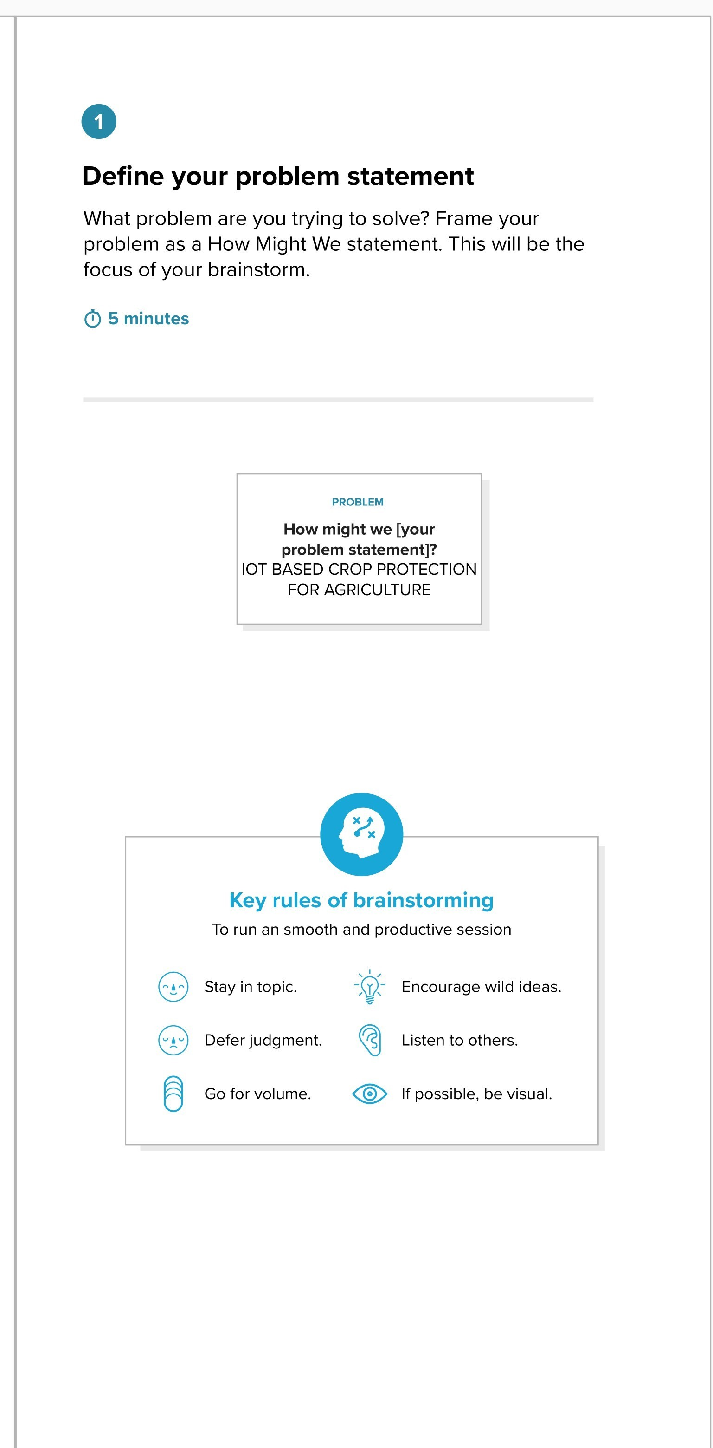

BrainstormBrainstorm

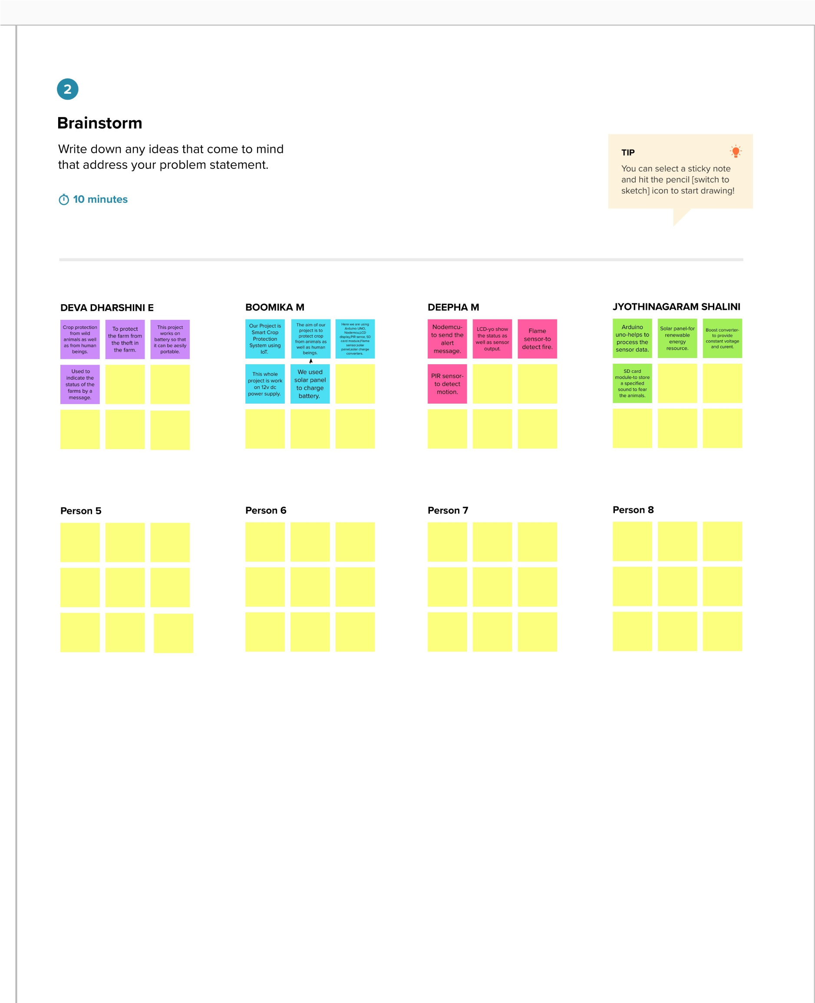

Group ideas

Group ideas

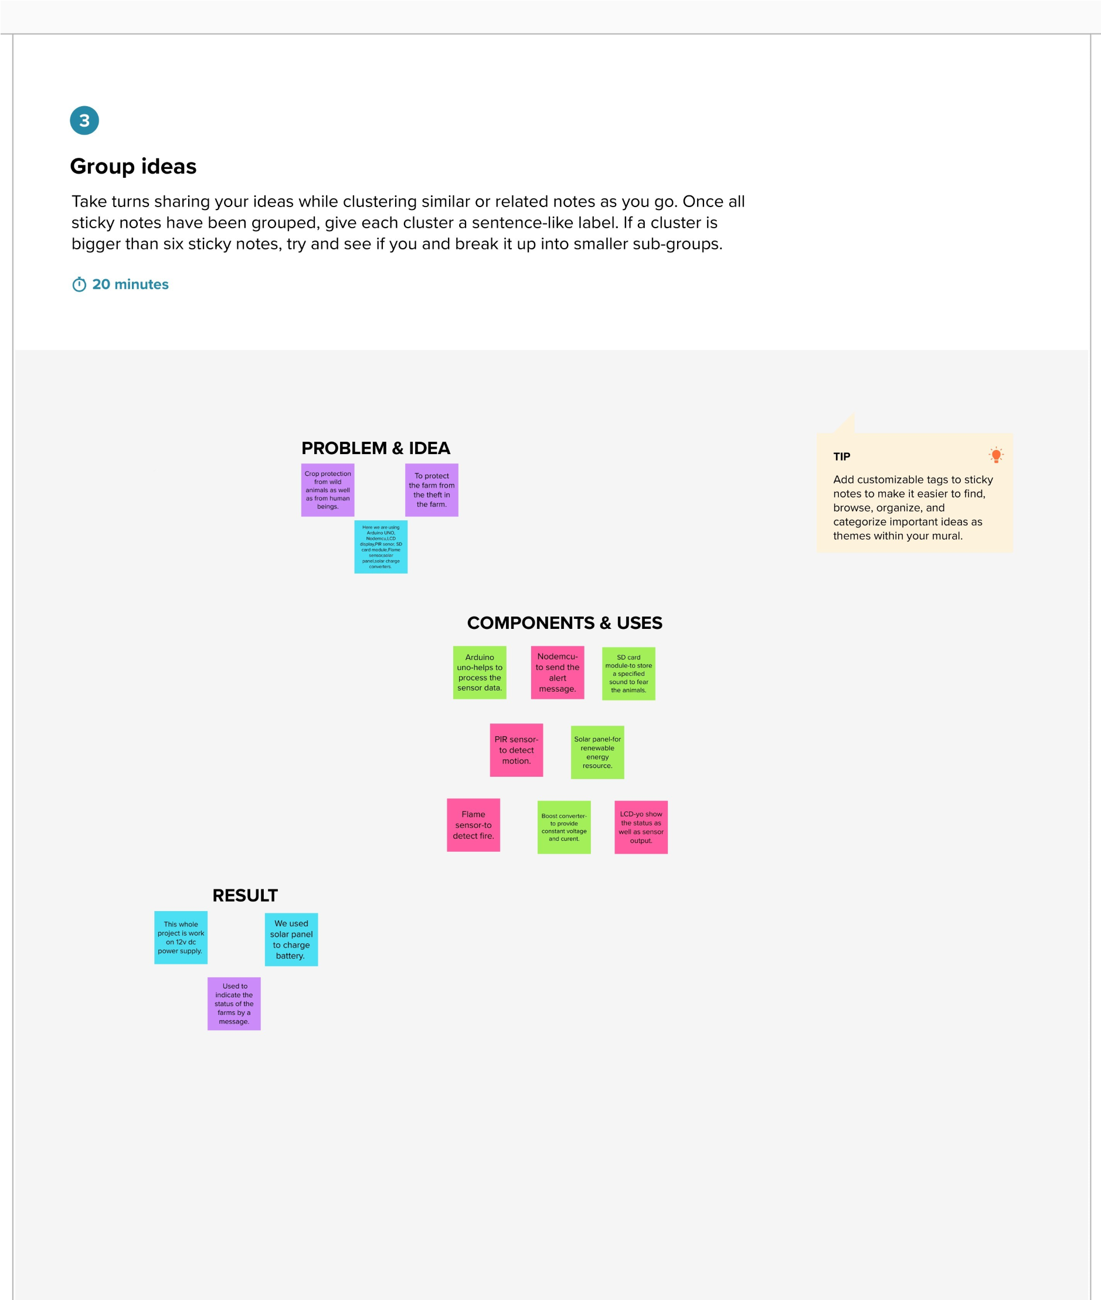

PrioritizationPrioritization

